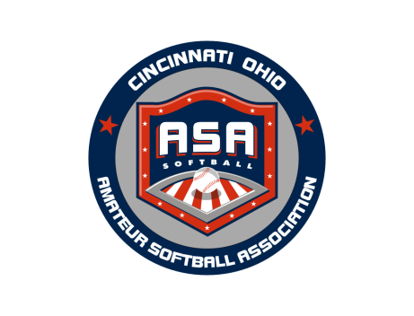 | Third Annual  Tri State USA Softball  Fall Golf Scramble | 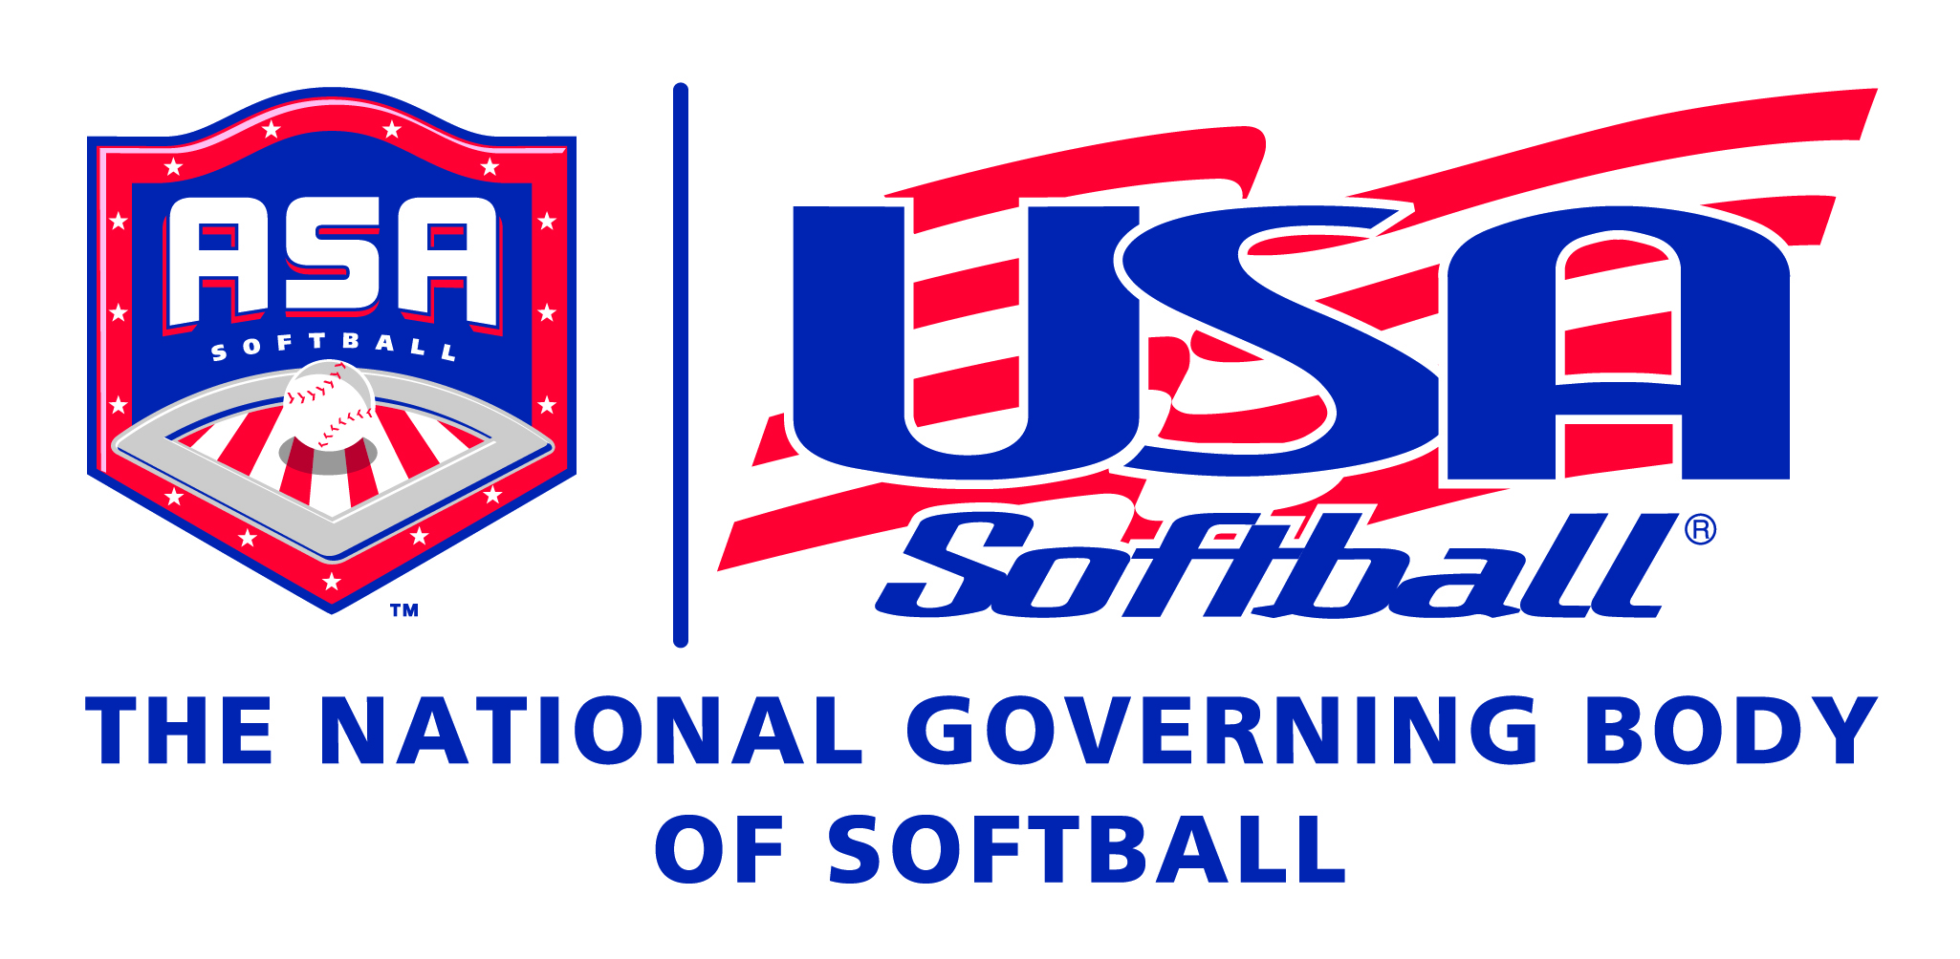
Sunday September 18, 2016
Please Help If You Can
Hole Sponsors $100
Or
Donations

Proceeds to Benefit
The Tri State USA Softball Girls Fast Pitch Program
For More Information
David Maury  513-310-6885  dmaury@cincinnatiasa.com |  | Mail Check or Money Order to  Cincinnati ASA  6797 River Road  Harrison, Ohio 45030

